**Feasibility Study**

Technical

Here are the specifications of the computer that I used at school in order to help complete the project, I will not be including the hardware specification of my home computer as it has better hardware and as this computer can easily run this website it is not necessary to comment on it. I will not be commenting on the hardware specification of my laptop as it was only used for commentary of some of my files. Therefore, not affecting the running of the website itself in anyway

*CPU*

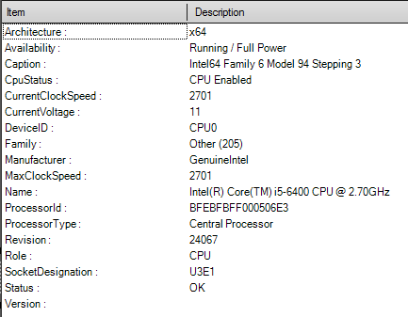

*RAM*

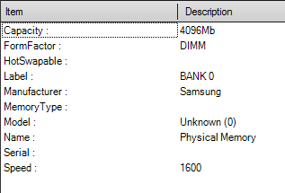

*STORAGE*

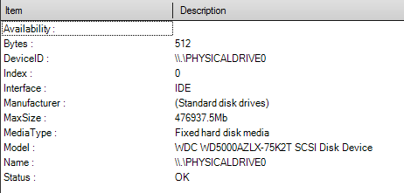

This computer is sufficient for my tasks, which include creating the website and running it.

Windows 7,10 and Ubuntu are the operating systems used for the duration of the project. The school computers will be updating to windows 10 during mid-October as well.

Notepad++, Vim and VSCode are the text editors/ IDE’s that are used for the project.

EasyPHP is what I'll be using to simulate a server and I can run it with the computer specs shown above.

Google chrome is the browser that I will be using to test the website at school and at home. The version I will be using is version 69.0.3497.100 (Official Build) (64-bit).

The user should have a mouse, keyboard and monitor as well.

Economic

My project will not incur any fees as I do not need to buy any software and I don't need to pay any workers as I am the only worker on this project. Hardware is already provided by the school and I also have the correct software and hardware to work on my project at home and on my laptop so there is no need for me to pay for anything. This is only possible in an educational environment as the needed resources are presented to me by my school, as a company may have to buy the hardware necessary to create the software.

Legal

One possible legal ramification that I could face is from the Copyrights, Designs and Patents Act. Due to this act, I will have to be careful about what kinds of images I will use on my website as the use of someone else's work without their permission or acknowledgement would mean that I am plagiarising their work. Therefore, I will be careful not to use any intellectual property of others and only use graphics or other such intellectual property that I myself have created or that have the acknowledgement of their creators/ permission from the creator.

There won't be any legal problems because of the General Data Protection Regulation as I won't be collecting the data of people who are using my website as I do not want to have to deal with the hassle of it. So any personal data on my website would only be possible by the user openly posting the data on a public page or the like. Registration processes will not include the asking of personal data. Usernames and passwords would in an ideal world be encrypted, however this may not be possible due to time constraints and will not need be necessary in a test environment.

My project will not have to deal with the computer misuse act as I won't be using it as a piece of malware to say steal user data or install malware onto the user's computer.

I will not have to deal with the communications act as I will my project will not involve any of the below:

* Access and use someone else's Wi-Fi connection without their permission.
* Send, by means of a public electronic communications network a message or other matter that is grossly offensive or of an indecent, obscene or menacing character.
* Send, for the purpose of causing annoyance, inconvenience or needless anxiety to another by means of a public electronic communications network, a message that he/she knows to be false.

However, users of my website may need to be careful about what they say on it as the above will apply to them. Meaning that I may have to log messages and backup relevant data consistently and perhaps even have to deal with RIPA. Which entails the below:

* The ability to demand that an Internet Service Provider provide details of a customer's communications.
* Allows mass surveillance of communications by monitoring phone and internet communications
* Gives permission to force ISPs to fit equipment to their systems to make surveillance easier.
* Allows bodies to demand public and private encryption access keys are handed over so that encrypted messages may be decrypted.
* Allows the bodies to keep the above activities secret!

However as this is just a class project I don't really need to worry about it.

Schedule

This project will be feasible in the given time. That is between September and the Easter holidays. The project will however be delayed at multiple points of the year between these dates with one such delay being due to university interviews. Another being holidays such as the Christmas holiday which will last about two and a half weeks and prelims which will cover the first two weeks of the January month. In addition to the above, time will be lost due to some chance events such as the disappearance of all of my work during one of the dates in the September month and the loss of all my HTML and CSS during the December month. Special events such as the writing of my personal statement, university open days and projects for other subjects will also take up some time. However as mentioned earlier, the project will still be feasible in the given time.

End Statement

In conclusion, this project will be feasible in all the ways shown above. I have the technical requirements, economic and legal requirements along with the schedule planned out so that everything can be done in the given time frame even with delays due to various events.